3 YEAR OLD PROGRAM
ENROLMENT AND WAITING LIST POLICY

PURPOSE

To define the process for 3 year old enrolment in the 3 year old Kindergarten program to ensure that families joining the Pre-School are aware of their obligations.

REQUIREMENTS

- The child must be 3 years old by 30th April in the year of attendance and cannot attend sessions until they have turned 3 years old. (Normal term fees will apply for this period i.e. If the child does not turn three until April, Term 1 fees must still be paid in full).
- The 3 year old group will run one group, with two sessions per week totalling six hours.
- A teacher with the equivalent of a Bachelor in Early Childhood, one Educator with the equivalent of a Diploma in Early Childhood and one Educator with the equivalent with a Certificate III in Early Childhood, will operate the 3 year old program
- On 1st January 2016, new legislation known as “No Jab No Play” commenced in Victoria. From this date, all children enrolling in early childhood education and care service are required to be up to date with their immunisations or have an approved exemption.

ENROLMENT PROCEDURE

The Enrolment Period

Applications for prospective children will be accepted during the enrolment period:
- The enrolment period will open on the 1st Sunday in May each year (which is the Elonera Open Day) and will close on the Friday, 13 days later. Enrolment is open until the last mail on that Friday.
Applications must be received by the Friday, 13 days later in the last mail received. Applications will be accepted only upon receipt of: the application form, the payment of a non-refundable $20.00 Application Fee per child, acknowledgement of the Enrolment policy, along with a copy of the child's Birth Certificate or Extract (required for proof of age).

Applications

Application forms will be available from the Enrolment Officer or the Pre-School website, www.elonerapreschool.com.au for a week prior to the enrolment period. No enrolments will be accepted until the Elonera Open Day on the first Sunday in May.

Any person telephoning the Pre-School for an application form should be directed to contact the Enrolment Officer. The Enrolment Officer can answer any questions and mail an application form and record the caller’s details. In the case of multiple birth families, one application form needs to be completed per child.

Families will need to acknowledge they have read the Enrolment and Waiting list policy. This will be available online, in the foyer of the kinder or a copy can be mailed to families as requested.

ALLOCATION OF PLACES

All applications received during the enrolment period will be given equal consideration based on the criteria set out in the “Weighted Priority System”. The enrolment period is open for a period of 13 days as stated previously, and closes the year prior to attendance.

Any previous outstanding fees owed by families to Elonera Pre-School must be paid in full before a child is eligible to be allocated a place in the 3 Year Old program. If outstanding fees are not paid in full, then a child will not be eligible to receive a place in the program.

The Enrolment Officer will first consult with the 3 Year Old Teacher before the allocation of any places in the 3 Year Old Kindergarten program in the event of a child having to repeat a year in that 3 Year Old program.

Remaining places will then be allocated and the waiting list compiled as per the weighted priority system. If there is an equal number or greater number of places than applicants then all applicants will receive an offer of a place.

Notifications of a placement in the 3 Year Old program at Elonera are sent out at the same time as the offers for Elonera’s 4 Year Old program. These dates are set by the City of Kingston with allocations commencing in July each year.

WEIGHTED PRIORITY SYSTEM

To be offered a position the completed application must have been received in the enrolment period in the year prior to attendance. The application form must be complete with the child’s proof of age attached and the non-refundable $20 application fee paid. Parents who wish their child to repeat the 3 Year Old Kindergarten program at Elonera, without recommendation from the teacher must re-enrol their child via the normal enrolment period.

If there are more applicants than places then the following weighted priority system will apply. If there is an excess of children meeting any of the criteria then a ballot will take place which will be drawn by the Enrolment Officer and overseen by members of the Executive Committee.

- Criteria One
Children having a second year in the 3 year old program at the recommendation of the teacher.

- Criteria Two
Any child currently attending, or who has a sibling who has attended, Elonera Pre-School from most, to least recent.

- Criteria Three
Children who live within the boundary - map attached

- Criteria Four
All other children

Where the total number of applications exceeds the number of places, additional children will be placed on a waiting list, in order of the weighted priority system.

Applications received after the closing of the enrolment period will be allocated vacancies/ or placed on the bottom of the waiting list, in order of date of application received.

ADDITIONAL NEEDS SUPPORT FOR 3YO

Teachers can apply to Yooralla for an additional year in the 4 Year Old Group program only. This is funded by DET.

NOTE: There is no funding available from DET for 3 Year Old programs. Alternative arrangements must be made for inclusion of children with additional needs in the 3 Year Old program (e.g. parents provide support).

CHILDREN REQUIRING AN ADDITIONAL YEAR

This policy acknowledges the difference between parent choice and teacher request for a child repeating 3 Year Old. If child is enrolled in the 3 Year Old program in the year prior to the application, the 3 Year Old Teacher will inform the Enrolment Officer of those children requiring a second year in the 3 Year Old Kindergarten program. A child will be offered a placement, above all others, in the 3 Year Old Kindergarten program if the child is likely to have another year whilst continuing the year in the 3 year old program, after consultation between the teacher and the parent/ guardian in Term One or Two.

Parents who wish their child to repeat the 3 Year Old Kindergarten program at Elonera, without recommendation from the teacher must re-enrol their child via the normal enrolment period.
Parents requesting a second year application for their child, will need to submit an application through the enrolment period.

The appropriate paperwork must still be completed once the decision to repeat has been made.

Families of children with birth dates between 1st January and 30th April have a choice about whether their child will commence school in the year they turn five or the following year. We strongly recommend that if your child’s birthday falls between these dates that you consider
when you would like them to commence school and if this is the year you need to send your child to 3 year old kinder.

OFFER AND ACCEPTANCE OF PLACES

Families receiving an offer of placement must return their acceptance along with 25% of their First term fees within 10 working days of the offer being made.

Parents, who withdraw their child after accepting a position, forfeit their initial 25% First term fees payment.

If no acceptance and 25% fee deposit payment is not received by this date and all reasonable attempts have been made by the Enrolment Officer to contact the family, the child’s name will be placed at the bottom of the waiting list for a further 10 working days.

If no correspondence either verbally or written is received by this date and all reasonable attempts have been made by the Enrolment Officer to contact the family the child’s name will be removed from the waiting list.

Elonera Pre-School does not consider an enrolment is complete until all forms have been returned and reviewed by Pre-School staff and Term 1 fees are paid by October 31 in the year prior to attendance.

NOTE: Invoices for Term 1 fees are issued at the beginning of October. The fees need to be paid in full by 31st October. If the fees are not received by this time, the kinder reserves the right to withdraw its offer of a place. Payment can be made by cheque, money order or direct deposit. If you have any issues regarding payments please contact the treasurer.

WAITING LIST

Applications received after number 28 will be sent a letter acknowledging their place on the waiting list. Families have 10 working days to return their acceptance of a place on the waiting list.

If no confirmation of acceptance of place on waiting list is received after 10 working days and all reasonable attempts have been made by the Enrolment Officer to contact the family, the child’s name will be moved to the bottom of the waiting list. The date for the 10 working day cut off will be specifically stated within the letter of offer (waiting place).

All payments must be made by direct deposit, cheque or money order. Cash will not be accepted other than as outlined in the Fee Policy.

Any applications that are received after the enrolment period will be added to the waiting list in order of date of application received. All application forms should be accompanied by a birth certificate, acknowledgement form of enrolment policy and a non-refundable admin fee of $20.

If a position becomes available during the year for the current 3 year old program (after 4 year old offers have been sent out) first preference will be given to the next child on the waiting list who has been offered a 4 year old position for the following year.

WITHDRAWAL AND NON-ATTENDANCE OF AN ACCEPTED PLACE

An enrolled child who fails to attend the 3 year old program for a period of four weeks, without communication to Elonera regarding absence will be deemed to have vacated their position. The Enrolment Officer will make reasonable attempts to contact the family prior to re-allocating their place. At the conclusion of four weeks with no parental communication, the place will then be allocated to the next child on the waiting list.

A parent who wishes to withdraw their child from the kinder program must formally withdraw their child by placing this notification in writing to the Teacher and the Secretary of the Committee of Management. Parents remain liable for fees as per fee policy until formal notification is received.

BOUNDARY FOR 3 YEAR OLD ENROLMENTS

As per Weighted Priority System -- Persons applying that live outside the Boundary will still be accepted in the Enrolment Process but need to be aware of the Weighted Priority System in place.

The boundary is bordered by Lower Dandenong Road to Long Street. From Long Street along Nepean Highway to Warrigal Road. South along Warrigal Road to Como Parade East. Along Como Parade East to White Street. Along White Street to Nepean Highway. North Along Nepean Highway then east up and including Ashmore Avenue, Collocott Street and David Street and Warren Road to Collocott Street Roundabout. Continuing along White Street and south into Bradshaw Street. The eastern border incorporates all streets up to and including Bradshaw, Verbena & Scarlett Street, re-joining at Lower Dandenong Road.

Please refer to Map

Map

Lower Dandenong Road
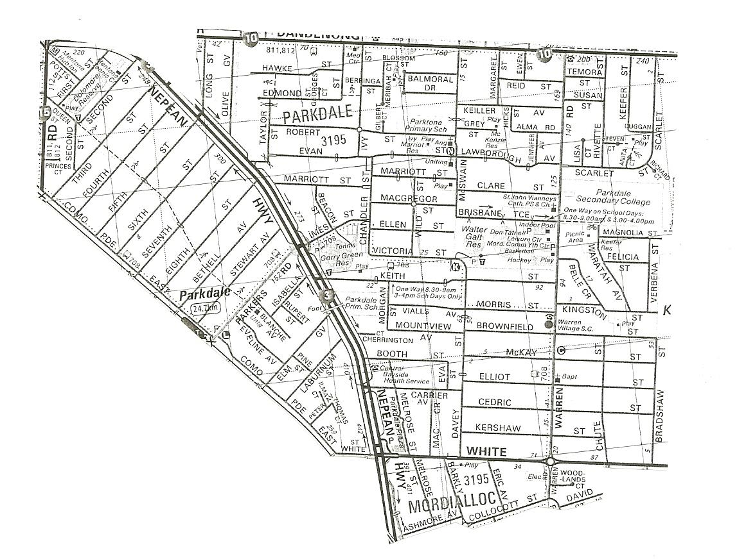

Authorisation
This policy was reviewed and adopted by the Committee of Management on 19th April 2018.

Review date: 23/04/2019

