ANAPHYLAXIS POLICY
Mandatory – Quality Area 2

PURPOSE
This policy will provide guidelines to:
- minimise the risk of an anaphylactic reaction occurring while children are in the care of Elonera Pre-School
- ensure that service staff respond appropriately to an anaphylactic reaction by following the child’s ASCIA action plan for anaphylaxis, including competently administering adrenaline via an auto-injection device
- raise awareness of anaphylaxis and its management amongst all at the service through education and policy implementation.
- This policy should be read in conjunction with the Dealing with Medical Conditions Policy

POLICY STATEMENT

VALUES
Elonera Pre-School believes that the safety and wellbeing of children who are at risk of anaphylaxis is a whole-of-community responsibility, and is committed to:
- providing a safe and healthy environment in which children at risk of anaphylaxis can participate fully in all aspects of the program
- raising awareness of families, staff, children and others attending the service about allergies and anaphylaxis
- actively involving the parents/guardians of each child at risk of anaphylaxis in assessing risks, and in developing risk minimisation and risk management strategies for their child
- ensuring all staff members and other adults at the service have adequate knowledge of allergies, anaphylaxis and emergency procedures
- facilitating communication to ensure the safety and wellbeing of children at risk of anaphylaxis.

SCOPE
This policy applies to the Approved Provider, Nominated Supervisor, Certified Supervisor, educators, staff, students on placement, volunteers, parents/guardians, children and others attending the programs and activities of Elonera Pre-School. This policy will apply regardless of whether a child diagnosed by a registered medical practitioner as being at risk of anaphylaxis is enrolled at the service.

BACKGROUND AND LEGISLATION

Background
Anaphylaxis is a severe and potentially life-threatening allergic reaction. Up to two per cent of the general population and up to ten per cent of children are at risk. The most common causes of allergic reaction in young children are eggs, peanuts, tree nuts, cow’s milk, fish, soy , wheat and sesame, bee or other insect stings, and some medications. A reaction can develop within minutes of exposure to the allergen and young children may not be able to identify or articulate the symptoms of anaphylaxis. With planning and training, a reaction can be treated effectively by using an adrenaline auto-injection device, often called an EpiPen® or an Anapen®.
In any service that is open to the general community it is not possible to achieve a completely allergen-free environment. A range of procedures and risk minimisation strategies, including strategies to minimise the presence of allergens in the service, can reduce the risk of anaphylactic reactions.
Legislation that governs the operation of approved children’s services is based on the health, safety and welfare of children, and requires that children are protected from hazards and harm. At Elonera Preschool all educators on duty have current approved anaphylaxis management training (refer to Definitions).
Approved anaphylaxis management training is listed on the ACECQA website (refer to Sources).

Legislation and standards
Relevant legislation and standards include but are not limited to:
- Education and Care Services National Law Act 2010: Sections 167, 169
- Education and Care Services National Regulations 2011: Regulations 90–96, 102, 136, 137, 146, 147, 160–162, 168(2)(d), 173, 177, 181, 183, 184
- Health Records Act 2001(Vic), as amended 2011
- Privacy and Data Protection Act (2014)(Vic)
- National Quality Standard, Quality Area 2: Children’s Health and Safety
  - Standard 2.1: Each child’s health is promoted
    - Element 2.1.1: Each child’s health needs are supported
    - Element 2.1.4: Steps are taken to control the spread of infectious diseases and to manage injuries and illness, in accordance with recognised guidelines
  - Standard 2.3: Each child is protected
    - Element 2.3.3: Plans to effectively manage incidents and emergencies are developed in consultation with relevant authorities, practised and implemented
- Occupational Health and Safety Act 2004(Vic), as amended 2007
- Privacy Act 1988(Cth)
- Public Health and Wellbeing Act 2008(Vic)
- Public Health and Wellbeing Regulations 2009(Vic)

DEFINITIONS
The terms defined in this section relate specifically to this policy. For commonly used terms e.g. Approved Provider, Nominated Supervisor, Regulatory Authority etc. refer to the General Definitions section of this manual.
Anaphylaxis action plan: Refer to the definition for anaphylaxis medical management action plan below.
Adrenaline auto-injection device: An intramuscular injection device containing a single dose of adrenaline designed to be administered by people who are not medically trained. This device is commonly called an EpiPen® or an Anapen®. As EpiPen® and Anapen® products have different administration techniques, only one brand should be prescribed per individual and their anaphylaxis medical management action plan (refer to Definitions) must be specific for the brand they have been prescribed. Used adrenaline auto-injectors should be placed in a rigid sharps disposal unit, or another rigid container if a sharps container is not available. These devices can only be used on a known anaphylaxis sufferer.
Adrenaline auto-injection device training: Training in the use of the adrenaline auto-injection device that is provided by allergy nurse educators or other qualified professionals such as doctors or first aid trainers, through accredited training institutions or through the use of a self-paced training CD and auto-injection device trainer.
Adrenaline auto-injector kit: An insulated container with an unused, in-date adrenaline auto-injection device, a copy of the child’s anaphylaxis medical management action plan, and telephone contact details for the child’s parents/guardians, doctor/medical personnel and the person to be notified in the event of a reaction if the parents/guardians cannot be contacted. If prescribed, an antihistamine should also be included in the kit. Auto-injection devices must be stored away from direct heat.
Allergen: A substance that can cause an allergic reaction.
Allergy: An immune system response to an external stimulus that the body identifies as an allergen. People genetically programmed to experience an allergic reaction will make antibodies to particular allergens.
Allergic reaction: A reaction to an allergen. Common signs and symptoms include one or more of the following: hives, tingling mouth, abdominal pain, vomiting and/or diarrhoea, facial swelling, coughing or wheezing, difficulty swallowing or breathing, loss of consciousness or collapse (child pale or floppy), or cessation of breathing.
- Mild to moderate signs & symptoms:
- hives or welts
- tingling mouth
- swelling of the face, lips & eyes
- abdominal pain, vomiting and/or diarrhoea are mild to moderate symptoms, however these are severe reactions to insects.
- Signs & symptoms of anaphylaxis are:
- difficult/noisy breathing
- swelling of the tongue
- swelling/tightness in the throat
- difficulty talking and/or hoarse voice
- wheeze or persistent cough
- persistent dizziness or collapse (child pale or floppy).

AV How to Call Card: A card that the service has completed containing all the information that Ambulance Victoria will request when phoned on 000. Once completed this card should be kept within easy access of all service telephone/s. A sample card can be downloaded from www.ambulance.vic.gov.au/Education/Calling-Triple-0.html
Anapen®: A type of adrenaline auto-injection device (refer to Definitions) containing a single dose of adrenaline. The administration technique in an Anapen® is different to that of the EpiPen®. Two strengths are available: an Anapen® and an Anapen Jr®, and each is prescribed according to a child’s weight. The Anapen Jr®is recommended for use when a child weighs more than 20kg. The child’s medical management action plan (refer to Definitions) must be specific for the brand they have been prescribed.
Anaphylaxis: A severe, rapid and potentially fatal allergic reaction that affects normal functioning of the major body systems, particularly the respiratory (breathing) and/or circulation systems.
Anaphylaxis medical management action plan(sometimes simply referred to as an Action Plan): An individual medical management plan prepared and signed by the child’s treating, registered medical practitioner that provides the child’s name and allergies, a photograph of the child, a description of the prescribed anaphylaxis medication for that child and clear instructions on treating an anaphylactic episode. The plan must be specific for the brand of auto-injection device prescribed for each child. Examples of plans specific to different adrenaline auto-injector brands are available for download on the Australasian Society of Clinical Immunology and Allergy (ASCIA) website: www.allergy.org.au/health-professionals/anaphylaxis-resources/ascia-action-plan-for-anaphylaxis
Anaphylaxis management training: Training that includes recognition of allergic reactions, strategies for risk minimisation and risk management procedures for emergency treatment and facilitates practise in the administration of treatment using an adrenaline auto-injection device (refer to Definitions) trainer. Approved training is listed on the ACECQA website (refer to Sources).
Approved anaphylaxis management training: Training that is approved by the National Authority in accordance with Regulation 137(e) of the Education and Care Services National Regulations 2011, and is listed on the ACECQA website (refer to Sources).
At-risk child: A child whose allergies have been medically diagnosed and who is at risk of anaphylaxis.
Communication plan: A plan that forms part of the policy outlining how the service will communicate with parents/guardians and staff in relation to the policy. The communication plan also describes how parents/guardians and staff will be informed about risk minimisation plans and emergency procedures to be followed when a child diagnosed as at risk of anaphylaxis is enrolled at a service.
Duty of care: A common law concept that refers to the responsibilities of organisations to provide people with an adequate level of protection against harm and all reasonable foreseeable risk of injury.
EpiPen®: A type of adrenaline auto-injection device (refer to Definitions) containing a single dose of adrenaline which is delivered via a spring-activated needle that is concealed until administration is required. Two strengths are available: an EpiPen® and an EpiPen Jr®, and each is prescribed according to a child’s weight. The EpiPen Jr® is recommended for a child weighing 10–20kg. An EpiPen® is recommended for use when a child weighs more than 20kg. The child’s anaphylaxis medical management action plan (refer to Definitions) must be specific for the brand they have been prescribed.
Intolerance: Often confused with allergy, intolerance is an adverse reaction to ingested foods or chemicals experienced by the body but not involving the immune system.
No food sharing: A rule/practice in which a child at risk of anaphylaxis only eats food that is supplied/permitted by their parents/guardians and does not share food with, or accept food from, any other person.
Nominated staff member: (In relation to this policy) a staff member nominated to be the liaison between parents/guardians of a child at risk of anaphylaxis and the Approved Provider. This person also checks regularly to ensure that the adrenaline auto-injector kit is complete and that the device itself is unused and in date, and leads practice sessions for staff who have undertaken anaphylaxis management training.
Risk minimisation: The practice of developing and implementing a range of strategies to reduce hazards for a child at risk of anaphylaxis, by removing, as far as is practicable, major allergen sources from the service.
Risk minimisation plan: A service-specific plan that documents a child’s allergy, practical strategies to minimise risk of exposure to allergens at the service and details of the person/s responsible for implementing these strategies. A risk minimisation plan should be developed by the relevant Educator in consultation with the parents/guardians of the child at risk of anaphylaxis and service staff. The plan should be developed upon a child’s enrolment or initial diagnosis, and reviewed at least annually and always on re-enrolment. A sample risk minimisation plan is provided as Attachment 3.
Staff file: Must be kept by the service for each staff member and volunteers. The record must include information about qualifications, training and details of the Working with Children Check (Regulations 146–149).

SOURCES AND RELATED POLICIES

Sources
- ACECQA provides lists of approved first aid training, approved emergency asthma management training and approved anaphylaxis management training on their website: http://acecqa.gov.au/qualifications/approved-first-aid-qualifications/
- Allergy &Anaphylaxis Australia is a not-for-profit support organisation for families of children with food-related anaphylaxis. Resources include a telephone support line and items available for sale including storybooks, tapes and EpiPen® trainers.www.allergyfacts.org.au
- Australasian Society of Clinical Immunology and Allergy (ASCIA): www.allergy.org.au
Provides information and resources on allergies. Action Plans for Anaphylaxis can be downloaded from this site. Also available is a procedure for the First Aid Treatment for Anaphylaxis (refer to Attachment 4). Contact details of clinical immunologists and allergy specialists are also provided.
- Department of Education and Training (DET) resources and information related to anaphylaxis and training. Anaphylaxis resource kits have been distributed to all Victorian licensed children’s services for the purpose of undertaking training in administration of an auto-infection device http://www.education.vic.gov.au/childhood/providers/health/Pages/anaphylaxis.aspx
- Department of Allergy and Immunology at The Royal Children’s Hospital Melbourne (www.rch.org.au/allergy/) provides information about allergies and services available at the hospital. This department can evaluate a child’s allergies and provide an adrenaline auto-injector prescription. An EpiPen® trainer kit can also be purchased. Kids Health Info fact sheets are also available from the website, including the following:
  - Allergic and anaphylactic reactions:http://www.rch.org.au/kidsinfo/fact_sheets/Allergic_and_anaphylactic_reactions/
Auto-injectors (epi-pens) for anaphylaxis – an overview: http://www.rch.org.au/kidsinfo/fact_sheets/Autoinjectors_epipens_for_anaphylaxis_an_overview/
The Royal Children's Hospital has been contracted by the Department of Education and Training (DET) to provide an Anaphylaxis Advice & Support Line to central and regional DET staff, school principals and representatives, school staff, children's services staff and parents/guardians wanting support. The Anaphylaxis Advice & Support Line can be contacted on
1300725911 or 9345 4235, or by email: carol.whitehead@rch.org.au

Service policies
- Administration of First Aid Policy
- Administration of Medication Policy
- Asthma Policy
- Dealing with Medical Conditions Policy
- Diabetes Policy
- Enrolment and Orientation Policy
- Excursions and Service Events Policy
- Food Safety Policy
- Hygiene Policy
- Incident, Injury, Trauma and Illness Policy
- Inclusion and Equity Policy
- Nutrition and Active Play Policy
- Privacy and Confidentiality Policy

PROCEDURES

The Approved Provider is responsible for:
- ensuring that an anaphylaxis policy, which meets legislative requirements and includes a risk minimisation plan (refer to Attachment 3) and communication plan, is developed and displayed at the service, and reviewed regularly
- providing approved anaphylaxis management training (refer to Definitions) to staff as required under the National Regulations
- ensuring that at least one educator with current approved anaphylaxis management training (refer to Definitions) is in attendance and immediately available at all times the service is in operation (Regulations 136, 137)
- ensuring the Nominated Supervisor, educators, staff members, students and volunteers at the service are provided with a copy of the Anaphylaxis Policy and the Dealing with Medical Conditions Policy
- ensuring parents/guardians of a child with allergies are provided with a copy of the Anaphylaxis Policy and the Dealing with Medical Conditions Policy(Regulation 91)
- ensuring that staff practice administration of treatment for anaphylaxis using an adrenaline
auto-injection device trainer quarterly, and that participation is documented in the staff file
- ensuring the details of approved anaphylaxis management training (refer to Definitions) are included on the staff record (refer to Definitions), including details of training in the use of an
- autoinjector (Regulations 145,146, 147)
- ensuring that parents/guardians or a person authorised in the enrolment record provide written consent to the medical treatment or ambulance transportation of a child in the event of an emergency (Regulation 161), and that this authorisation is kept in the enrolment record for each child
- ensuring that parents/guardians or a person authorised in the child’s enrolment record provide written authorisation for excursions outside the service premises (Regulation 102) (refer to Excursions and Service Events Policy)
- identifying children at risk of anaphylaxis during the enrolment process and informing staff.
- Following appropriate reporting procedures set out in the Incident, Injury, Trauma and Illness Policy in the event that a child is ill, or is involved in a medical emergency or an incident at the service that results in injury or trauma.

In services where a child diagnosed as at risk of anaphylaxis is enrolled, the Approved Provider is also responsible for:
- displaying a notice prominently at the service stating that a child diagnosed as at risk of anaphylaxis is being cared for and/or educated by the service (Regulation 173(2)(f))
- ensuring the Enrolment checklist for children diagnosed as at risk of anaphylaxis (refer to Attachment 2) is completed
- ensuring an anaphylaxis medical management action plan, risk management plan (refer to Attachment 3) and communications plan are developed for each child at the service who has been diagnosed as at risk of anaphylaxis, in consultation with that child’s parents/guardians and with a registered medical practitioner (Attachment 3)
- ensuring that all children diagnosed as at risk of anaphylaxis have details of their allergy, their anaphylaxis medical management action plan and their risk minimisation plan filed with their enrolment record (Regulation 162)
- ensuring a medication record is kept for each child to who medication is to be administered by the service (Regulation 92)
- ensuring parents/guardians of all children at risk of anaphylaxis provide an unused, in-date adrenaline auto-injection device at all times their child is attending the service. Where this is not provided, children will be unable to attend the service
- ensuring that the child’s anaphylaxis medical management action plan is specific to the brand of adrenaline auto-injection device prescribed by the child’s medical practitioner
- implementing a procedure for first aid treatment for anaphylaxis consistent with current national recommendations (refer to Attachment 4) and ensuring all staff are aware of the procedure
- ensuring adequate provision and maintenance of adrenaline auto-injector kits(refer to Definitions)
- ensuring the expiry date of the adrenaline auto-injection device is checked regularly and replaced when required
- implementing a communication plan and encouraging ongoing communication between parents/guardians and staff regarding the current status of the child’s allergies, this policy and its implementation (Regulation 90 (c) (iv A-B))
- identifying and minimising allergens (refer to Definitions)at the service, where possible
- ensuring measures are in place to prevent cross-contamination of any food given to children diagnosed as at risk of anaphylaxis(refer to Nutrition and Active Play Policy and Food SafetyPolicy)
- ensuring that children at risk of anaphylaxis are not discriminated against in any way
- ensuring that children at risk of anaphylaxis can participate in all activities safely and to their full potential
- immediately communicating any concerns with parents/guardians regarding the management of children diagnosed as at risk of anaphylaxis attending the service
- ensuring that medication is not administered to a child at the service unless it has been authorised and administered in accordance with Regulations 95 and 96 (refer to Administration of Medication Policy and Dealing with Medical Conditions Policy)
- ensuring that parents/guardians of a child and emergency services are notified as soon as is practicable if medication has been administered to that child in an anaphylaxis emergency without authorisation from a parent/guardian or authorised nominee (Regulation 94)
- ensuring that a medication record is kept that includes all details required by Regulation 92(3) for each child to who medication is to be administered
- ensuring that written notice is given to a parent/guardian as soon as is practicable if medication is administered to a child in the case of an emergency
- responding to complaints and notifying DET,in writing and within 24 hours, of any incident or complaint in which the health, safety or wellbeing of a child may have been at risk

Risk assessment
The National Law and National Regulations do not require a service to maintain a stock of adrenaline autoinjectors at the service premises to use in an emergency. However, ELAA recommends that the Approved Provider undertakes a risk assessment in consultation with the Nominated Supervisor and other educators, to inform a decision on whether the service should carry its own supply of these devices. This decision will also be informed by considerations such as distance to the nearest medical facility and response times required for ambulance services to reach the service premises etc.
If the Approved Provider decides that the service should maintain its own supply of adrenaline autoinjectors, it is the responsibility of the Approved Provider to ensure that:
· adequate stock of the adrenaline autoinjector is on hand, and that it is unused and in date
· appropriate procedures are in place to define the specific circumstances under which the device supplied by the service will be used
· the autoinjector is administered in accordance with the written instructions provided on it and with the generic ASCIA action plan for anaphylaxis
· the service follows the procedures outlined in the Administration of Medication Policy, which explains the steps to follow when medication is administered to a child in an emergency
· parents/guardians are informed that the service maintains a supply of adrenaline autoinjectors, of the brand that the service carries and of the procedures for the use of these devices in an emergency.

- displaying the Australasian Society of Clinical Immunology and Allergy (ASCIA) (refer to Sources) generic poster Action Plan for Anaphylaxis in key locations at the service
- displaying Ambulance Victoria’s AV How to Call Card(refer to Definitions)near all service telephones
- complying with the risk minimisation procedures outlined in Attachment 1
- ensuring that educators/staff who accompany children at risk of anaphylaxis outside the service carry a fully equipped adrenaline auto-injector kit(refer to Definitions) and a copy of the anaphylaxis medical management action plan for each child diagnosed as at risk of anaphylaxis.

Elonera Preschool acknowledges that it is best practice to stock an additional adrenaline autoinjector when they have a child enrolled who has been identified as at risk of anaphylaxis. It is illegal for an adrenaline autoinjector to be administered to a child who is not a known anaphylactic sufferer, therefore no device will be kept on the premises when there is no known sufferer attending the facility. Due to the current shortage of adrenaline autoinjector’s in Australia they are now a prescription only medicine. Until the supply increases Elonera will be unable to provide an additional centre autoinjector.

The Nominated Supervisor is responsible for:
- identifying children at risk of anaphylaxis during the enrolment process and informing staff.
- ensuring the Enrolment checklist for children diagnosed as at risk of anaphylaxis (refer to Attachment 2) is completed
- ensuring that all educators’ approved first aid qualifications, anaphylaxis management training and emergency asthma management training are current, meet the requirements of the National Act (Section 169(4))and National Regulations (Regulation 137), and are approved by ACECQA (refer to Sources)
- ensuring that medication is not administered to a child at the service unless it has been authorised and administered in accordance with Regulations 95 and 96 (refer to Administration of Medication Policy and Dealing with Medical Conditions Policy)
- ensuring that parents/guardians of a child and emergency services are notified as soon as is practicable if medication has been administered to that child in an anaphylaxis emergency without authorisation from a parent/guardian or authorised nominee (Regulation 94)
- ensuring educators and staff are aware of the procedures for first aid treatment for anaphylaxis (refer to Attachment 4)
- ensuring an adrenaline auto-injector kit(refer to Definitions)is taken on all excursions and other offsite activities (refer to Excursions and Service Events Policy)
- compiling a list of children at risk of anaphylaxis and placing it in a secure but readily accessible location known to all staff. This should include the anaphylaxis medical management action plan for each child
- ensuring that all staff, including casual and relief staff, are aware of children diagnosed as at risk of anaphylaxis, their allergies and symptoms, and the location of their adrenaline auto-injector kits and medical management action plans
- ensuring measures are in place to prevent cross-contamination of any food given to children diagnosed as at risk of anaphylaxis(refer to Nutrition and Active Play Policy and Food SafetyPolicy)
- organising anaphylaxis management information sessions for parents/guardians of children enrolled at the service, where appropriate
- ensuring that all persons involved in the program, including parents/guardians, volunteers and students on placement are aware of children diagnosed as at risk of anaphylaxis
- ensuring programmed activities and experiences take into consideration the individual needs of all children, including children diagnosed as at risk of anaphylaxis
- following the child’s anaphylaxis medical management action plan in the event of an allergic reaction, which may progress to an anaphylactic episode
- practising the administration of an adrenaline auto-injection device using an auto-injection device trainer and ‘anaphylaxis scenarios’ quarterly
- ensuring that the adrenaline auto-injector kit is stored in a location that is known to all staff, including casual and relief staff, is easily accessible to adults both indoors and outdoors (not locked away) but inaccessible to children, and away from direct sources of heat
- ensuring that parents/guardians or an authorised person named in the child’s enrolment record provide written authorisation for children to attend excursions outside the service premises (Regulation 102) (refer to Excursions and Service Events Policy)
- providing information to the service community about resources and support for managing allergies and anaphylaxis
- complying with the risk minimisation procedures outlined in Attachment 1.

Certified Supervisors, other educators and staff are responsible for:
- reading and complying with the Anaphylaxis Policy and the Dealing with Medical Conditions Policy
- maintaining current approved anaphylaxis management qualifications (refer to Definitions)
- practising the administration of an adrenaline auto-injection device using an auto-injection device trainer and ‘anaphylaxis scenarios’ quarterly
- ensuring they are aware of the procedures for first aid treatment for anaphylaxis (refer to Attachment 4)
- completing the Enrolment checklist for children diagnosed as at risk of anaphylaxis (refer to Attachment 2) with parents/guardians
- knowing which children are diagnosed as at risk of anaphylaxis, their allergies and symptoms, and the location of their adrenaline auto-injector kits and medical management action plans
- identifying and, where possible, minimising exposure to allergens (refer to Definitions) at the service
- following procedures to prevent the cross-contamination of any food given to children diagnosed as at risk of anaphylaxis (refer to Nutrition and Active Play Policy and Food Safety Policy)
- assisting with the development of a risk minimisation plan (refer to Attachment 3) for children diagnosed as at risk of anaphylaxis at the service
- following the child’s anaphylaxis medical management action plan in the event of an allergic reaction, which may progress to an anaphylactic episode
- taking the adrenaline auto-injector kit(refer to Definitions) for each child at risk of anaphylaxis on excursions or to other offsite service events and activities
- providing information to the service community about resources and support for managing allergies and anaphylaxis
- complying with the risk minimisation procedures outlined in Attachment 1
- contacting parents/guardians immediately if an unused, in-date adrenaline auto-injection device has not been provided to the service for a child diagnosed as at risk of anaphylaxis. Where this is not provided, children will be unable to attend the service
- discussing with parents/guardians the requirements for completing the enrolment form and medication record for their child
- consulting with the parents/guardians of children diagnosed as at risk of anaphylaxis in relation to the health and safety of their child, and communicating any concerns
- ensuring that children diagnosed as at risk of anaphylaxis are not discriminated against in any way and are able to participate fully in all activities.
- Following appropriate first aid procedures in the event that a child who has not been diagnosed as at risk of anaphylaxis appears to be having an anaphylactic episode (refer to attachment4)
- Informing the Approved Provider and the child’s parents/guardians following an anaphylactic episode

Parents/guardians of a child at risk of anaphylaxis are responsible for:
- informing staff, either on enrolment or on initial diagnosis, of their child’s allergies
- completing all details on the child’s enrolment form, including medical information and written authorisations for medical treatment, ambulance transportation and excursions outside the service premises
- assisting the Approved Provider and staff to develop an anaphylaxis risk minimisation plan (refer to Attachment 3)
- providing staff with an anaphylaxis medical management action plan signed by a registered medical practitioner and with written consent to use medication prescribed in line with this action plan
- providing staff with an unused, in-date and complete adrenaline auto-injector kit
- ensuring that the child’s anaphylaxis medical management action plan is specific to the brand of adrenaline auto-injection device prescribed by the child’s medical practitioner
- regularly checking the adrenaline auto-injection device’s expiry date
- assisting staff by providing information and answering questions regarding their child’s allergies
- notifying staff of any changes to their child’s allergy status and providing a new anaphylaxis medical management action plan in accordance with these changes
- communicating all relevant information and concerns to staff, particularly in relation to the health of their child
- complying with the service’s policy where a child who has been prescribed an adrenaline
auto-injection device is not permitted to attend the service or its programs without that device
- complying with the risk minimisation procedures outlined in Attachment 1
- ensuring they are aware of the procedures for first aid treatment for anaphylaxis (refer to Attachment 4).

Parents/guardians are responsible for:
- reading and complying with this policy and all procedures, including those outlined in Attachment 1
- bringing relevant issues and concerns to the attention of both staff and the Approved Provider.

Volunteers and students, while at the service, are responsible for following this policy and its procedures.

EVALUATION
In order to assess whether the values and purposes of the policy have been achieved, the Approved Provider will:
- selectively audit enrolment checklists (for example, annually) to ensure that documentation is current and complete
- regularly seek feedback from everyone affected by the policy regarding its effectiveness
- monitor the implementation, compliance, complaints and incidents in relation to this policy
- keep the policy up to date with current legislation, research, policy and best practice
- revise the policy and procedures as part of the service’s policy review cycle or following an anaphylactic episode at the service, or as otherwise required
- notify parents/guardians at least 14 days before making any changes to this policy or its procedures.

ATTACHMENTS
- Attachment 1: Risk minimisation procedures
- Attachment 2: Enrolment checklist for children diagnosed as at risk of anaphylaxis
- Attachment 3: Sample risk minimisation plan
- Attachment 4: First Aid Treatment for Anaphylaxis
- Attachment 5: Communication Plan Flowchart
- Attachment 6: Procedure for management of Elonera supplied auto-injection device
- Attachment 7: Template of risk minimisation plan used by educators

AUTHORISATION
This policy was adopted by the Elonera Pre-School Committee of Management on 23/01/2013.
This policy was reviewed & updated by the Elonera Pre-School Committee of Management on 18/03/2015.
This policy was reviewed and approved by the Elonera Pre-School Committee of Management on 11/03/2021

REVIEW DATE: March 2024
ATTACHMENT 1
Risk minimisation procedures
The following procedures should be developed in consultation with the parents/guardians of children in the service who have been diagnosed as at risk of anaphylaxis, and implemented to protect those children from accidental exposure to allergens. These procedures should be regularly reviewed to identify any new potential for accidental exposure to allergens.

In relation to the child diagnosed as at risk:
- the child should only eat food that has been specifically prepared for him/her. Some parents/guardians may choose to provide all food for their child
- ensure there is no food sharing (refer to Definitions), or sharing of food utensils or containers at the service
- where the service is preparing food for the child:
  - ensure that it has been prepared according to the instructions of parents/guardians
  - parents/guardians are to check and approve the instructions in accordance with the risk minimisation plan
- bottles, other drinks, lunch boxes and all food provided by parents/guardians should be clearly labelled with the child’s name
- consider placing a severely allergic child away from a table with food allergens. However, be mindful that children with allergies should not be discriminated against in any way and should be included in all activities
- ensure appropriate supervision of the child diagnosed as at risk of anaphylaxis on special occasions such as excursions and other service events
- children diagnosed as at risk of anaphylaxis who are allergic to insect/sting bites should wear shoes and long-sleeved, light-coloured clothing while at the service.

In relation to other practices at the service:
- ensure tables, high chairs and bench tops are thoroughly cleaned after every use
- ensure that all children and adults wash hands upon arrival at the service, and before and after eating
- supervise all children at meal and snack times, and ensure that food is consumed in specified areas. To minimise risk, children should not move around the service with food
- do not use food of any kind as a reward at the service
- ensure that children’s risk minimisation plans inform the service’s food purchases and menu planning
- ensure that staff and volunteers who are involved in food preparation and service undertake measures to prevent cross-contamination of food during the storage, handling, preparation and serving of food, including careful cleaning of food preparation areas and utensils (refer to Food Safety Policy)
- request that all parents/guardians avoid bringing food to the service that contains specified allergens or ingredients as outlined in the risk minimisation plans of children diagnosed as at risk of anaphylaxis
- restrict the use of food and food containers, boxes and packaging in crafts, cooking and science experiments, according to the allergies of children at the service
- ensure staff discuss the use of foods in children’s activities with parents/guardians of at-risk children. Any food used at the service should be consistent with the risk management plans of children diagnosed as at risk of anaphylaxis
- ensure that garden areas are kept free from stagnant water and plants that may attract biting insects.
ATTACHMENT 2
Enrolment checklist for children diagnosed as at risk of anaphylaxis
☐ A risk minimisation plan is completed in consultation with parents/guardians prior to the attendance of the child at the service, and is implemented including following procedures to address the particular needs of each child diagnosed as at risk of anaphylaxis.
☐ Parents/guardians of a child diagnosed as at risk of anaphylaxis have been provided with a copy of the service’s Anaphylaxis Policy and Dealing with Medical Conditions Policy.
☐ All parents/guardians are made aware of the service’s Anaphylaxis Policy.
☐ An anaphylaxis medical management action plan for the child is completed and signed by the child’s registered medical practitioner and is accessible to all staff.
☐ A copy of the child’s anaphylaxis medical management action plan is included in the child’s adrenaline auto-injector kit(refer to Definitions).
☐ An adrenaline auto-injection device (within a visible expiry date) is available for use at all times the child is being educated and cared for by the service.
☐ An adrenaline auto-injection device is stored in an insulated container (adrenaline auto-injector kit) in a location easily accessible to adults both indoors and outdoors (not locked away) but inaccessible to children, and away from direct sources of heat.
☐ All staff, including casual and relief staff, are aware of the location of each adrenaline auto-injector kit and the location of each child’s anaphylaxis medical management action plan.
☐ All staff have undertaken approved anaphylaxis management training (refer to Definitions), which includes strategies for anaphylaxis management, risk minimisation, recognition of allergic reactions and emergency first aid treatment. Details regarding qualifications are to be recorded in the staff file (refer to Definitions).
☐ All staff have undertaken practise with an auto-injection device trainer quarterly. Details regarding participation in practice sessions are to be recorded in the staff file (refer to Definitions).
☐ A procedure for first aid treatment for anaphylaxis is in place and all staff understand it (refer to Attachment 4).
☐ Contact details of all parents/guardians and authorised nominees are current and accessible.
☐ Information regarding any other medications or medical conditions in the service (for example asthma) is available to staff.
☐ If food is prepared at the service, measures are in place to prevent cross-contamination of the food given to the child diagnosed as at risk of anaphylaxis.
ATTACHMENT 3
Sample risk minimisation plan
The following information is not a comprehensive list but contains some suggestions to consider when developing/reviewing your service’s risk minimisation plan in consultation with parents/guardians.
How well has the service planned for meeting the needs of children with allergies and those who have been diagnosed as at risk of anaphylaxis?
Who are the children? | ☐ List names and room locations of each child diagnosed as at risk.
What are they allergic to? | ☐ List all known allergens for each child at risk.  ☐ List potential sources of exposure to each known allergen and strategies to minimise the risk of exposure. This will include requesting certain foods/items not be brought to the service.
Do staff (including casual and relief staff), volunteers and visiting staff recognise the children at risk? | ☐ List the strategies for ensuring that all staff, including casual and relief staff, recognise each at-risk child, are aware of the child’s specific allergies and symptoms and the location of their anaphylaxis medical management action plan.  ☐ Confirm the location of each child’s anaphylaxis medical management action plan and ensure it contains a photo of the child.
Do families and staff know how the service manages the risk of anaphylaxis? | ☐ Record the date on which each family of a child diagnosed as at risk of anaphylaxis is provided a copy of the service’s Anaphylaxis Policy.  ☐ Record the date that parents/guardians provide an unused, in-date and complete adrenaline auto-injector kit.  ☐ Test that all staff, including casual and relief staff, know the location of the adrenaline auto-injector kitand anaphylaxis medical management action plan for each  at-risk child.  ☐ Ensure that there is a procedure in place to regularly check the expiry date of each adrenaline auto-injection device.  ☐ Ensure a written request is sent to all families at the service to follow specific procedures to minimise the risk of exposure to a known allergen. This may include strategies such as requesting specific items not be sent to the service, for example:  - food containing known allergens or foods where transfer from one child to another is likely e.g. peanut/nut products, whole egg, sesame or chocolate  - food packaging where that food is a known allergen  e.g. cereal boxes, egg cartons.
☐ Ensure a new written request is sent to all families if food allergens change.
☐ Ensure all families are aware of the service policy that no child who has been prescribed an adrenaline auto-injection device is permitted to attend the service without that device.
☐ Display the ASCIA generic poster Action Plan for Anaphylaxis in key locations at the service and ensure a completed Ambulance Victoria AV How to Call Card is next to all telephone/s.
☐ The adrenaline auto-injector kit, including a copy of the anaphylaxis medical management action plan, is carried by an educator when a child diagnosed as at risk is taken outside the service premises e.g. for excursions.
Has a communication plan been developed which includes procedures to ensure that:  - all staff, volunteers, students and parents/guardians are informed about the policy and procedures for the management of anaphylaxis at Elonera Pre-School  - parents/guardians of a child diagnosed as at risk of anaphylaxis are able to communicate with service staff about any changes to the child’s diagnosis or anaphylaxis medical management action plan  - all staff, including casual, relief and visiting staff, volunteers and students are informed about, and are familiar with, all anaphylaxis medical management action plans and the Elonera Pre-School risk management plan. | ☐ All parents/guardians of a child with allergies are provided with a copy of the Anaphylaxis Policy prior to commencing at  Elonera Pre-School.  ☐ A copy of this policy is displayed in a prominent location at the service.  ☐ Staff will meet with parents/guardians of a child diagnosed as at risk of anaphylaxis prior to the child’s commencement at the service and will develop an individual communication plan for that family.  ☐ An induction process for all staff and volunteers includes information regarding the management of anaphylaxis at the service including the location of adrenaline  auto-injector kits, anaphylaxis medical management action plans, risk minimisation plans and procedures, and identification of children at risk.
Do all staff know how the service aims to minimise the risk of a child being exposed
to an allergen?
Think about times when the child could potentially be exposed to allergens and develop appropriate strategies including identifying the person responsible for implementing them (refer to the following section for possible scenarios and strategies).
☐ Hygiene procedures and practices are followed to minimise the risk of cross-contamination of surfaces, food utensils or containers by food allergens (refer to Hygiene Policy and Food Safety Policy).
☐ Consider the safest place for the at-risk child to be served and to consume food, while ensuring they are not discriminated against or socially excluded from activities.
☐ Develop procedures for ensuring that each at-risk child only consumes food prepared specifically for him/her.
☐ Ensure each child enrolled at the service washes his/her hands upon arrival at the service, and before and after eating.
☐ Employ teaching strategies to raise the awareness of all children about anaphylaxis and the importance of no food sharing (refer to Definitions) at the service.
☐ Bottles, other drinks, lunch boxes and all food provided by the family of the at-risk child should be clearly labelled with the child’s name.

Do relevant people know what action to take if a diagnosed child has an anaphylactic episode?
☐ Know what each child’s anaphylaxis medical management action plan contains and implement the procedures.
☐ Know:
- who will administer the adrenaline auto-injection device and stay with the child
- who will telephone the ambulance and the parents/guardians of the child
- who will ensure the supervision of other children at the service
- who will let the ambulance officers into the service and take them to the child.
☐ Ensure all staff have undertaken approved anaphylaxis management training and participate in regular practise sessions.
☐ Ensure a completed Ambulance Victoria AV How to Call Card is located next to all telephone/s.

Do relevant people know what action to take if an undiagnosed child has an anaphylactic episode?
☐ Know where Elonera supplied auto-injection device is located.
☐ Know the specific circumstances in which the Elonera supplied auto-injection device should be administered
☐ Know:
- who will administer the adrenaline auto-injection device and stay with the child
- who will telephone the ambulance and the parents/guardians of the child
- who will ensure the supervision of other children at the service
- who will let the ambulance officers into the service and take them to the child.

Potential exposure scenarios and strategies
How effective is the service’s risk minimisation plan?
☐ Review the risk minimisation plan of each child diagnosed as at risk of anaphylaxis with parents/guardians at least annually, but always on enrolment and after any incident or accidental exposure to allergens.

Scenario | Strategy | Who is responsible?
Party or celebration | Give parents/guardians adequate notice of the event. | Nominated Supervisor and educators
 | Ensure safe food is provided for the child diagnosed as at risk of anaphylaxis. | Parents/guardians and staff
 | Ensure the child diagnosed as at risk of anaphylaxis only eats food approved by his/her parents/guardians. | Staff
 | Specify a range of foods that all parents/guardians may send for the party and note particular foods and ingredients that should not be sent. | Approved Provider and Nominated Supervisor
Protection from insect bite allergies | Specify play areas that are lowest risk to the child diagnosed as at risk and encourage him/her and peers to play in that area. | Educators
 | Decrease the number of plants that attract bees or other biting insects. | Approved Provider
 | Ensure the child diagnosed as at risk of anaphylaxis wears shoes at all times they are outdoors. | Educators
 | Respond promptly to any instance of insect infestation. It may be appropriate to request exclusion of the child diagnosed as at risk during the period required to eradicate the insects. | Approved Provider/Nominated Supervisor
Latex allergies | Avoid the use of party balloons or latex gloves. | Staff
Cooking with children | Ensure parents/guardians of the child diagnosed as at risk of anaphylaxis are advised well in advance and included in the planning process. Parents/guardians may prefer to provide the ingredients themselves.  Ensure activities and ingredients used are consistent with risk minimisation plans. | Approved Provider, Nominated Supervisor and educators

ATTACHMENT 4
First Aid Treatment for Anaphylaxis
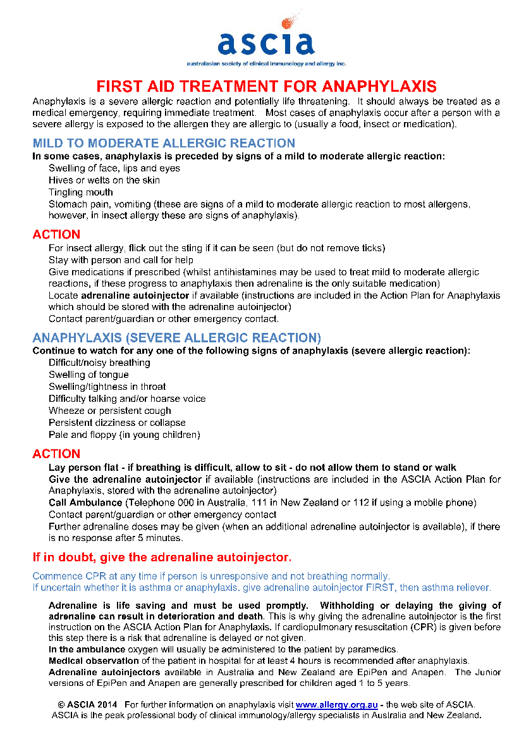
ATTACHTMENT 5
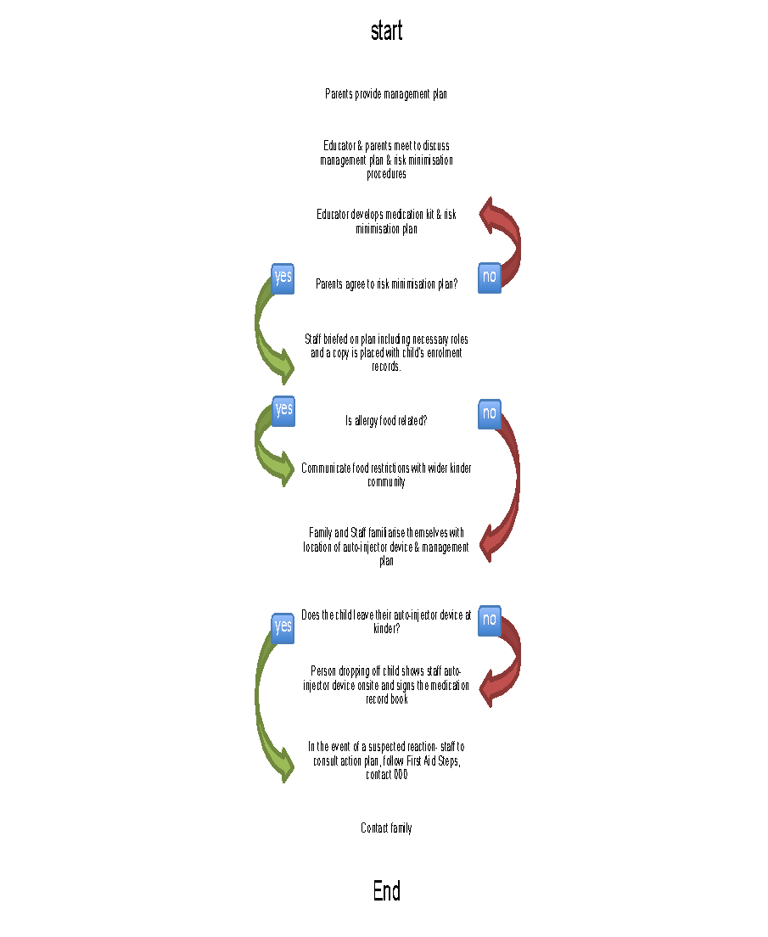
ATTACHTMENT 6
Management of Elonera supply of auto-injector
Decision made to stock Epipen brand when a child identified as being at risk of anaphylaxis is enrolled in the kindergarten.
- On set up day Nominated Supervisor to check the expiry date of auto –injector device and mark date on First Aid list
- Elonera supplied device would only be administered to a person
  - who is having an anaphylactic reaction that does not have their own device.
  - once any other prescribed medication for that individual was administered first with no result
  - who is having a reaction that matches the identified ASCIA First Aid steps (see Attachment 4)
  - when 000 gives permission to administer

- All staff have undertaken approved anaphylaxis management training and participate in regular practise sessions.
- Staff are aware of the location of the Elonera supplied auto-injector device
- Staff are aware of the steps to take prior to administering Elonera supplied auto-injector device
- Staff follow the procedures outlined in the Administration of Medication policy in regards to administering medication to a child in an emergency
- Parents/guardians of a child at risk of anaphylaxis reaction must still provide providing staff with an unused, in-date and complete adrenaline auto-injector kit. If this is not supplied the child cannot attend kinder.
- Device will only be used as noted above

NOTE: Due to the current shortage of adrenaline autoinjector’s in Australia they are now a prescription only medicine. Until the supply increases Elonera will be unable to provide an additional centre autoinjector.

ATTACHMENT 7: TEMPLATE OF RISK MINIMISATION PLAN COMPLETED BY EDUCATORS

ANAPHYLAXIS RISK MANAGEMENT PLAN
This plan is to be completed by the educator on the basis of information from the student's medical practitioner (ASCIA Action Plan for Anaphylaxis) provided by the Parent.
It is the Parents' responsibility to provide the Kindergarten with a copy of the student's ASCIA Action Plan for Anaphylaxis containing the emergency procedures plan (signed by the student's Medical Practitioner) and an up-to-date photo of the student - to be appended to this plan; and to inform the kindergarten if their child's medical condition changes.
Kindergarten |  | Phone
Student
DOB |  | Year level
Severely allergic to:

Other health conditions

Medication at kindergarten

EMERGENCY CONTACT DETAILS (PARENT)
Name |  | Name
Relationship |  | Relationship
Home phone |  | Home phone
Work phone |  | Work phone
Mobile |  | Mobile
Address |  | Address

EMERGENCY CONTACT DETAILS (ALTERNATE)
Name |  | Name
Relationship |  | Relationship
Home phone |  | Home phone
Work phone |  | Work phone
Mobile |  | Mobile
Address |  | Address

Medical practitioner contact |  | Name
 |  | Phone
Emergency care to be provided at kindergarten
Storage for Adrenaline Autoinjector (device specific) (EpiPen®/ Anapen®)

ENVIRONMENT
To be completed by educator. Please consider each environment/area (on and off kindergarten site) the student will be in for the year, e.g. classroom, outdoor area, excursions etc.
Name of environment/area:
Risk identified | Actions required to minimise the risk |  |  | Who is responsible? | Completion date?
Name of environment/area:
Risk identified | Actions required to minimise the risk |  |  | Who is responsible? | Completion date?
Name of environment/area:
Risk identified | Actions required to minimise the risk |  |  | Who is responsible? | Completion date?
Name of environment/area:
Risk identified | Actions required to minimise the risk |  |  | Who is responsible? | Completion date?
Name of environment/area:
Risk identified | Actions required to minimise the risk |  |  | Who is responsible? | Completion date?

This Individual Anaphylaxis Management Plan will be reviewed on any of the following occurrences (whichever happen earlier):
- annually;
- if the student's medical condition, insofar as it relates to allergy and the potential for anaphylactic reaction, changes ;
- as soon as practicable after the student has an anaphylactic reaction at Kindergarten; and
- when the student is to participate in an off-site activity, such as excursions, or at special events conducted, organised or attended by the Kindergarten (eg. class parties, cultural days,incursions).
I have been consulted in the development of this Individual Anaphylaxis Management Plan.
I consent to the risk minimisation strategies proposed.
Risk minimisation strategies are available at Chapter 8 - Prevention Strategies of the Anaphylaxis Guidelines
Printed name and signature of parent:
Date:
I have consulted the Parents of the students and the relevant Kindergarten Staff who will be involved in the implementation of this Individual Anaphylaxis Management Plan.
Printed Name and signature of Nominee:

Date:

