Bush Kinder Delivery & Collection of Children Policy
NQS: Quality Area 2

Purpose
This policy is a special circumstance policy, which augments the main Elonera Preschool Delivery & Collection of Children Policy and should be read in conjunction with that policy. This Bush Kinder policy details the specific delivery and collection requirements and procedures for children attending the Bush Kinder program. Only those requirements that are different to the main Elonera Preschool Delivery and Collection of Children Policy are listed here.

The requirements of the main Delivery & Collection of Children Policy are applicable to Bush Kinder, including for example, Late Collection of a Child, Authorisation Procedures and Procedures for Unauthorised Collection of Children.

Policy statement

1. Values
Elonera Preschool is committed to:
- Ensuring the safe delivery and collection of children participating in Bush Kinder
- Fulfilling a duty of care to all children participating in Bush Kinder

2. Scope
This policy applies to parents, staff, committee members, authorised persons, volunteers and students on placement working at Elonera Preschool.

3. Background and legislation
Refer to Background and Legislation of main Delivery & Collection of Children Policy for legislative requirements in relation to Duty of Care, Supervision and Collection of Children.
Relevant legislation may include but is not limited to:
● Education and Care Services National Regulations 2011
● Education and Care Services National Law 2010
● National Quality Standard

4. Definitions
Attendance Sheet: The sheet provided by the centre for the person who delivers and collects the child from the preschool, or a staff member, to sign and record the actual time of arrival and departure of each child being cared for or educated by the preschool. At Bush Kinder, the attendance sheet is located at the Bush Kinder site at the main meeting point. Parents/Guardians volunteering for the day will also be required to sign their arrival and departure on the attendance sheet.

Bush Kinder Site: The Bush Kinder site is located at Braeside Park, Braeside. Families are to enter the Park from Lower Dandenong Road. The home bush kinder site is located at the Federation Picnic Area. Refer to map at Attachment 1. Parking for drop off and collection is from the Braeside Park Swallow Car Park Area.

Delivery / Drop-off Point: The drop off point is at the home base as designated in the orientation session at Braeside Park at the area shown on the map at Attachment 1.

Delivery/Drop-off Procedure: Refer to Procedures section.

Parking Area: Ample car parking is available within Braeside Park.

Pick-up /Collection Point: The collection point is the same as the drop off/delivery point at Braeside Park at the area shown on the map at Attachment 1. If the Bush Kinder group has been forced to change locations due to safety reasons (eg extreme weather), parents will be notified by Story Park and Messagebird of the new location for collection, refer to evacuation plan policy.

Pick-up/Collection Procedure: Refer to Procedures section

5. Sources and related kindergarten policies
Kindergarten policies
● Delivery & Collection of Children (main kindergarten policy)
● Excursion & Regular Outing Policy
● Bush Kinder Protective Clothing Policy (Bush Kinder Specific)
● Bush Kinder Extreme Weather Policy (Bush Kinder Specific)
● Bush Kinder Identification and Visibility Policy (Bush Kinder Specific)
● Bush Kinder Emergency Evacuation Policy (Bush Kinder Specific)
● Bush Kinder Dog Awareness Policy (Bush Kinder Specific)
● Occupational Health & Safety Policy
● Incident, Illness, Trauma & Illness Policy
● Clothing Policy
● Sun Protection Policy
● Water Safety Policy
● Supervision of Children Policy
● Child Safe Environment Policy

Procedures - General
The Committee is responsible for:
- Providing parents with information regarding the procedures for delivery and collection of their children to and from Bush Kinder, and a summary of this policy prior to their child/ren’s attendance at Bush Kinder.
- Ensuring that a copy of this policy is available on request and is easily accessible to parents and staff at all times.
- Ensuring that all parents being aware of this policy and are provided access to the policy at orientation sessions, in written Bush Kinder material and on the Bush Kinder section of the Elonera website, and made available upon request.
- Ensuring staff and volunteers are appropriately educated on procedures detailed in this policy.

Staff are responsible for:
- Reading this policy and ensuring that the procedures detailed in this policy are carried out.
- Bringing relevant issues to the attention of the Committee
- Reminding parents of the policy content as required.

Parents are responsible for:
- Reading and being familiar with the policy
- Bringing relevant issues to the attention of both staff and committee
- We request that siblings do not attend Bush Kinder sessions, however parents are required to fully supervise siblings if they do attend the Bush Kinder session.

Delivery
Staff are responsible for:
- Ensuring the attendance sheet is located at the Bush Kinder site
- Checking the clothing of children arriving at Bush Kinder (Refer to Protective Clothing Policy)
- Checking the attendance sheet after all children have arrived (approximately 15 minutes after the commencement of the session) and if required, completing entries. This includes checking that children who are signed in are in attendance.
- Reminding parents or authorised persons who do not complete the attendance sheet of the procedures for the delivery and collection of children from Bush Kinder.

Parents are responsible for:
- Adhering to the following delivery procedure:
- Sign the child in using the attendance sheet and record the actual time of arrival
- Place child’s bag/backpack with change of clothes (refer to Protective Clothing Policy) in nominated area
- Ensure the staff are aware your child is in attendance.

Note: If on arrival, Bush Kinder is not set up on site, this means that the session has been cancelled (for example, due to extreme forecast weather or staff absence) the session will then be implemented at our home base site located at Elonera Preschool.

Collection
Staff are responsible for:
- Ensuring the attendance sheet is located at the Bush Kinder site.
- Notifying parents by Messagebird by 7.30am of the day of the session if the Bush Kinder group has been forced to change locations due to safety reasons (eg extreme weather, staff absence) and advising them of the new location for collection.
- Checking the attendance sheet as soon as is practicable after all children have departed and, if required, staff will complete entries
- Requesting parents or authorised persons wishing to speak with staff that they will need to wait until all of the children have departed
- Refer to main Delivery and Collection of Children Policy for full procedures relating to releasing children to authorised persons, in the event of an unauthorised person taking the child, and late collection & fees

Parents are responsible for:
- Adhering to the following collection procedure:
- Sign the child out using the attendance sheet and record the actual time of collection.
- Ensure the staff are aware you have collected your child.
- Be responsible for the supervision of the child once signed out, while still at the Bush Kinder site.
- Collect the child’s belongings (bag, water, hats)
- Being mindful of minimising staff distraction until all of the children have departed.
- Refer to main Delivery and Collection of Children Policy for full procedures relating to collection by authorised person, late collection and late collection fees.

Evaluation
In order to assess whether the policy has achieved the values and purposes the committee of management will:

- Seek feedback regarding this policy and its implementation with parents of children participating in the Bush Kinder program. This can be facilitated through discussions and the annual centre survey.
- Ask staff to share their experiences and observations in relation to the effectiveness of this policy.
- Regularly review the policy and centre practices to ensure they are compliant with any new legislation, research or best practice procedures.

Attachments
Attachment 1: Bush Kinder Map

Authorisation
Endorsed by the Elonera Preschool Committee of Management on 18th August 2016.

This policy will be reviewed every year and is next due for formal Committee review in September 2022, unless deemed necessary earlier.

Reviewed 2021

Attachment 1: Delivery and Collection Point

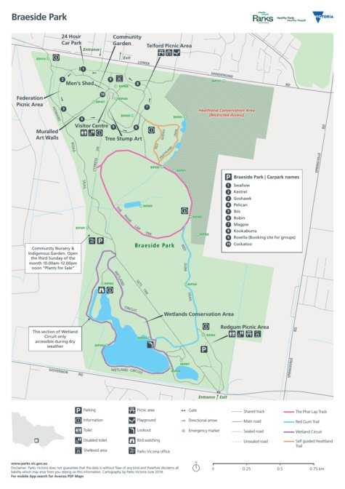
Base site
Drop-off/pick-up site

Drop off/Collection Parking Area – Magpie Car Park
Bush Kinder Base Site

